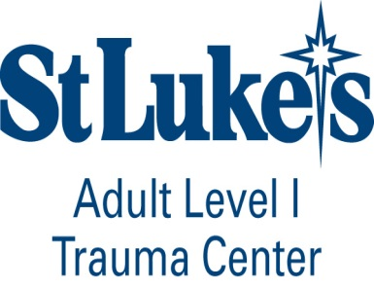
Advanced Trauma Life Support-ATLS
Registration Form-2018

Course Directors:
Richard Sharpe, MD, Peter Thomas, DO, William Hoff, MD
Course Coordinator:
Rachel O’Brien, M.Ed, Rachel.O’Brien@sluhn.org 484-526-3734

Name: _______________________________________________________MD DO PA-C CRNP
Position: Attending Fellow Resident Advanced Practitioner
Specialty: _________________________________Institution ________________________________

Home (Mailing) Address: ________________________________________________________________

_______________________________________________________________________________________

Residency Coordinator_____________________________________Phone_________________________

Email address: ____________________________ Date of Previous ATLS Course: _________________
ATLS Number:_________________________
Daytime phone: ______________________________Pager: _________________________________

2-Day Provider Course ____ ½-Day Renewal Course ____1 Day Instructor Course___
Please place a check by the course date you would like to attend:
Date of Course: April 18th-19th, 2018 (Wednesday/Thursday) ______________
July 13th, 2018 (Instructor Course-Friday) ____________
July 19th-20th, 2018(Thursday/Friday)________________
September 26th and 27th, 2018 (Wednesday/Thursday) ___________
December 13th-14th, 2018 (Thursday/Friday)____________
Course Tuition: Student Course -$700.00____ Student Renewal - $500____Instructor- $600.00____
Course tuition must accompany registration in order to reserve your seat in the course.
Payments: Credit Card
Type: _____M/C _____Visa Account number:______________________________________
Name as it appears on card:_____________________________ Expiration Date:____________
3 digit security code on back of card______________________
Checks should be made payable to: St. Luke’s Hospital-Trauma Division
Attention: Rachel O’Brien, M.Ed
801 Ostrum Street, Bethlehem, PA 18015.
Course materials will be shipped approximately 30 days prior to the course date.
CANCELLATION AND REFUND POLICY

The St. Luke’s Hospital ATLS Program reserves the right to cancel or postpone any course due to any unforeseen circumstances. In the event of cancellation or postponement, St. Luke’s ATLS Program will refund any registration fee but is not responsible for any related costs, charges or expenses to participants including cancellation of costs incurred by airlines/travel agencies.

Student Cancellation: Cancellation must be received in writing 2 weeks prior to course. Course tuition minus the cost of materials and $75 administration fee will be refunded to the participant. No refunds will be issued for student cancellations that are received less than two weeks prior to the course.

